Western Kentucky University hosts Campus Golf Expo
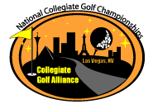
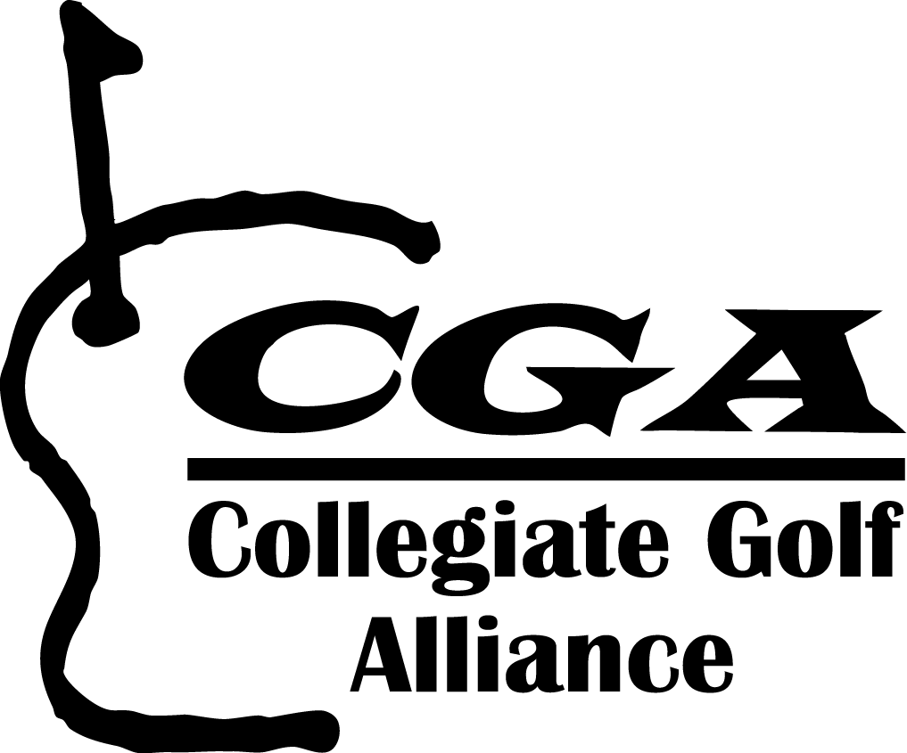
2010 National Collegiate Golf Championship
Wednesday May 12, 2012

Ryder Cup member Kenny Perry, 1982 WKU alumnus and nine-time winner on the PGA Tour will be hosting an on campus expo Ryder Cup member Kenny Perry, 1982 WKU alumnus and nine-time winner on the PGA Tour will be hosting an on campus expo Top of Form

For Immediate Release
April 28, 2012
www.cgagolflink.com
info@cgagolflinks.com
Collegiate Golf Alliance and The PGA of America have partnered to further promote golf on college campuses. With the PGA’s new Play Golf America University Program and CGA’s National Collegiate Golf Championship, golfers of all levels can get in the game on the center of WKU’s campus May 12th!
As a way to gain maximum exposure for the PGAU NCGC program, both on a campus and nationally, participating schools will conduct a Campus Golf Expo. This golf expo promotes the program and its sponsors, and highlights auxiliary events associated with the National Collegiate Golf Championship including the school’s Local Qualifying Tournament.
WKU will be hosting an on campus expo, a Local Qualifier Tournament and sending a student team to the National Championship.

Expo Date: Wednesday May 12, 2012
TIME/LOCATION
NCGC Local Qualifier Tournament Date: TBD
Registration link: http://www.cgagolflinks.com
“We are excited to be able to bring golf to the center of campus. Our CGA PGAU Golf Expo is a free interactive expo that promotes golf to players of all levels. Our goal is to stimulate interest in the university golf club, lesson programs, and recreational/competitive tournaments.” Stated CGA President and CEO Mike Munson.
During the expo schools free mini lessons, skills challenges, contests, hitting stations, a mini course on campus, and prizes. During the expo, students can sign up for the school’s local qualifying tournament to earn an invitation to the National Collegiate Golf Championship held in Las Vegas.

Schools use the almostGOLF ball for the CGA PGAU Campus Golf Expos. It’s a campus-safe, reduced flight ball and can be played on fields, quads or other open areas on campus. Golfweek Magazine named the product the “best product to impact the future of golf.”
For additional information regarding the WKY Expo and Tournament contact CGA PGAU Intern Chris Gottlick at 732.259.239 or christopher.gottlick481@wku.edu
Admin
Collegiate Golf Alliance
4790 Irvine Blvd STE 105-274
Irvine, Ca 92620
413-332-6038
www.cgagolflinks.com

Join us, follow us, look at us, watch us
CGAGolf

Bottom of Form

